Azure Coding Assessment

Name: Jeevan Sai Badana

Mail: [jeevansai100@gmail.com](mailto:jeevansai100@gmail.com)

Date: 28-02-2024

Question 1

1.Create Azure Devops Environment and configuring Azure Devops Git Repository ,configure on your local git to implement this upload few test files on same.

First we go to devops organisation

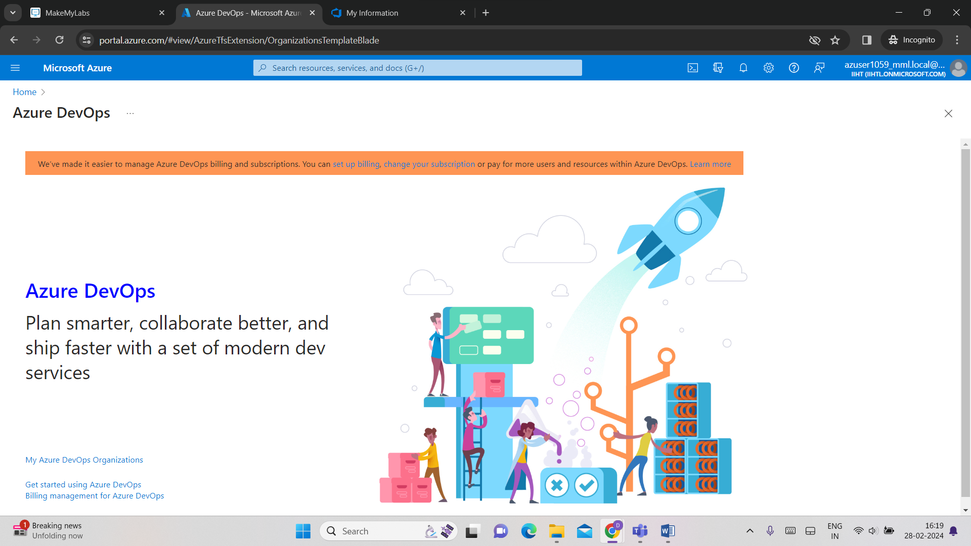

Create a new project

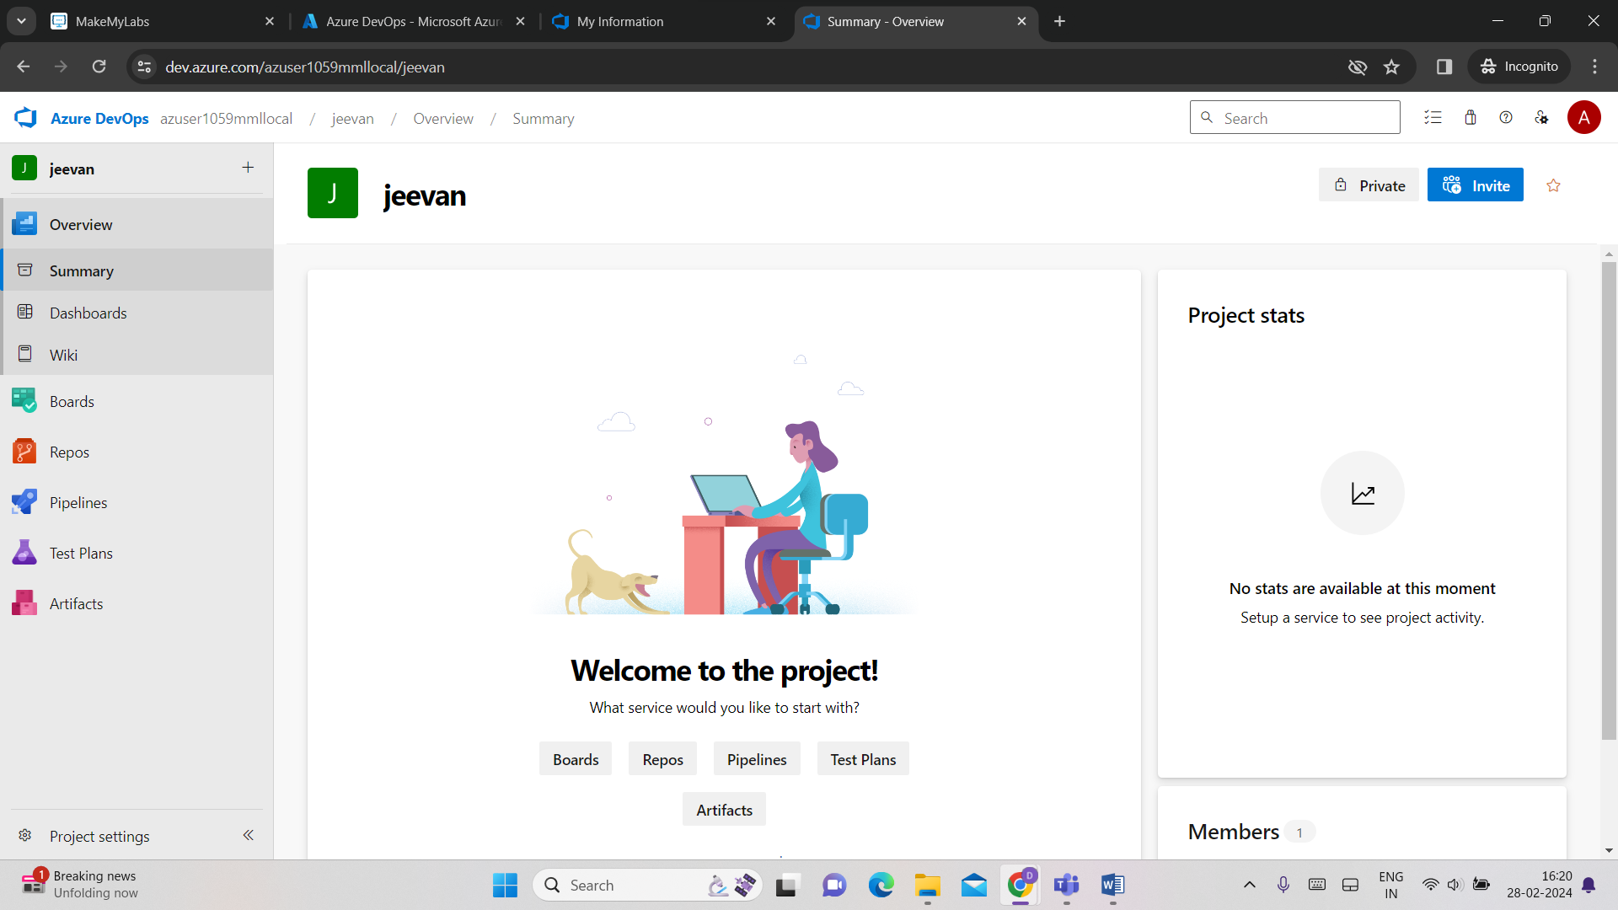

Now open git bash and execute commands

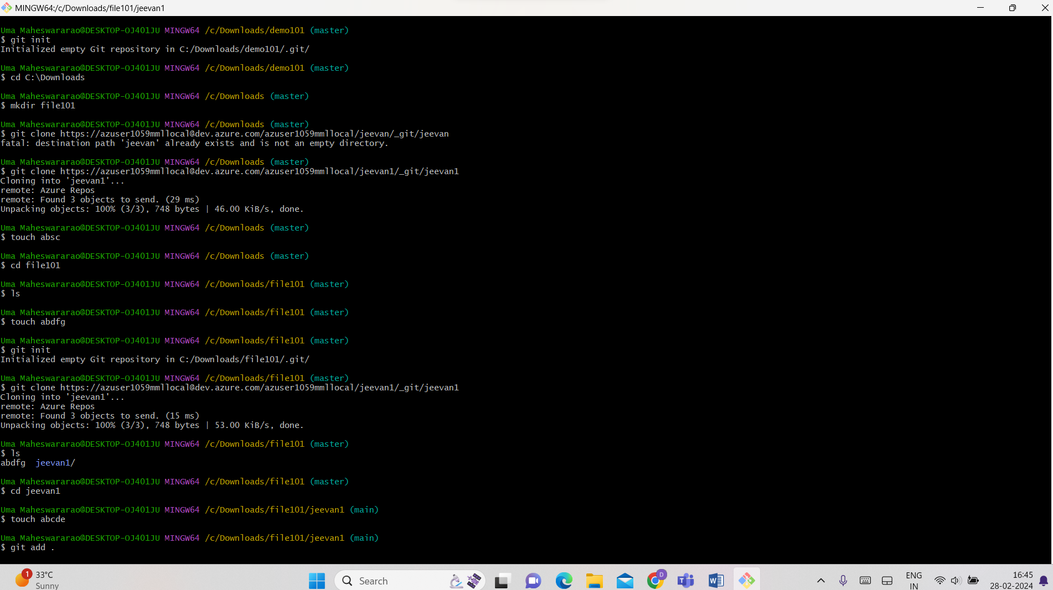

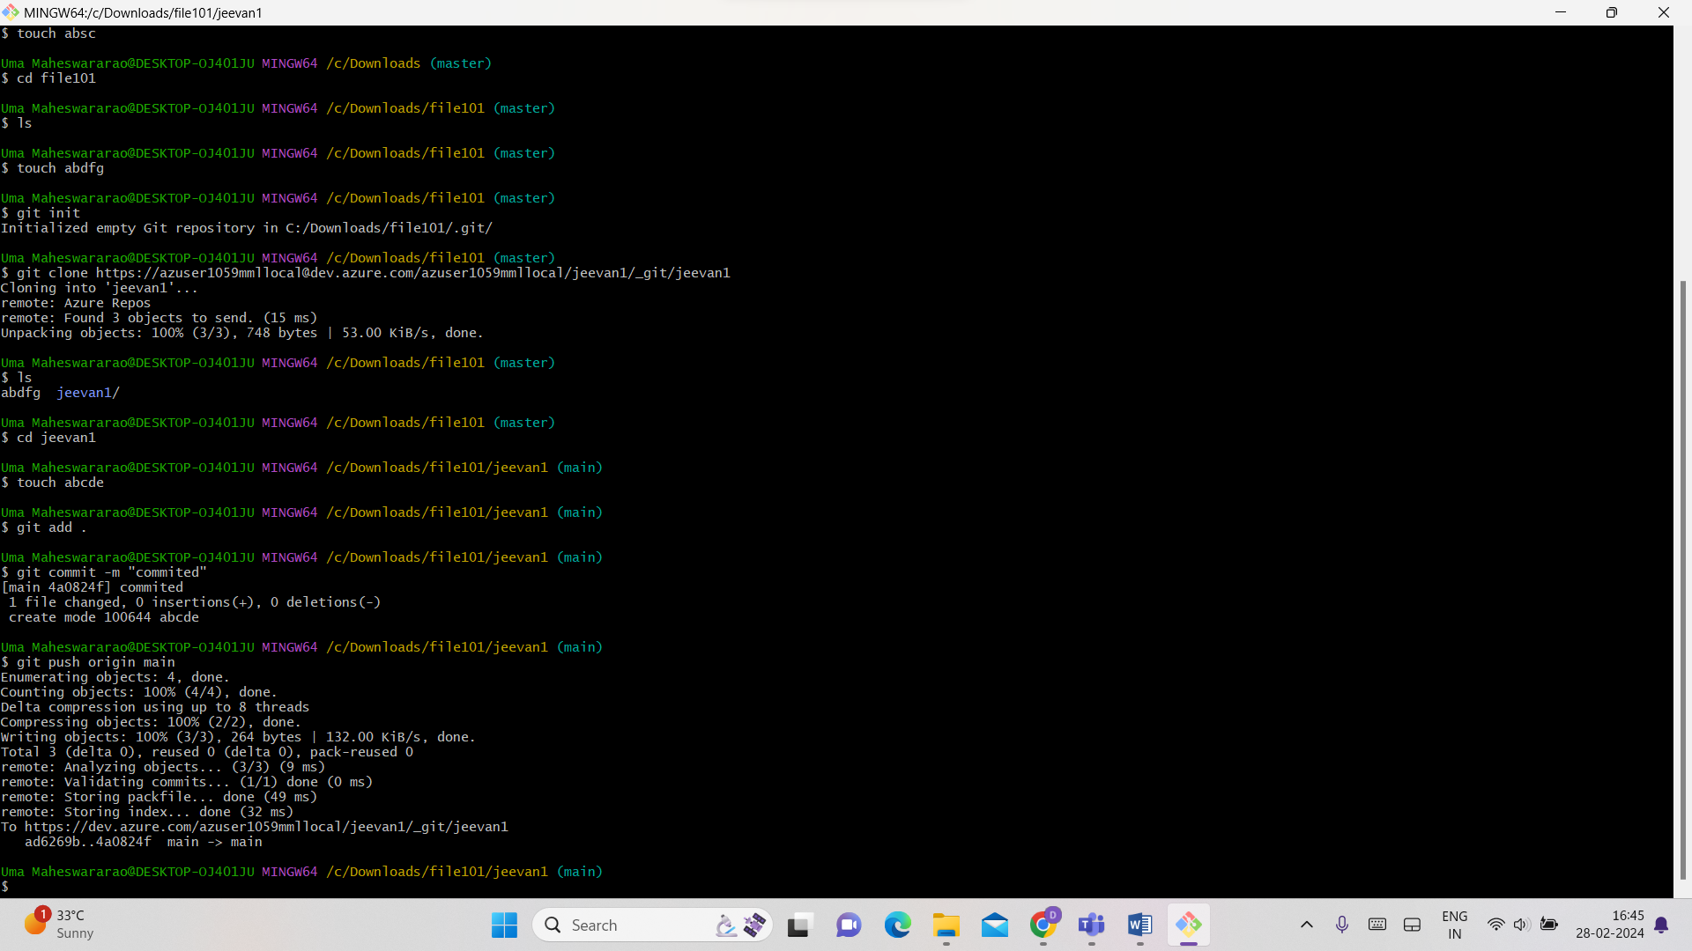

Now we check is the file correctly pushed or not

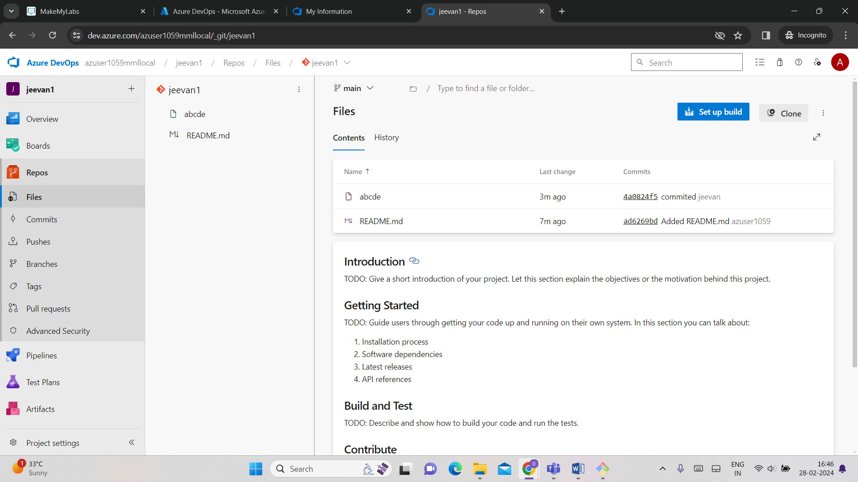

See there is file name abcde which we pushed now so it is successfully pushed to azure devops repos